**PLASMA DONOR APPLICATION**

__________________________________________________________________________________

* **Problem Statement**

With the number of people affected by COVID-19 infection the demand for the plasma of recovered patients has gone up tremendously. This creates chaotic situation for everyone as this is very crucial because this may risk many lives. So this situation needs a systematic and quick solution.

Searching eligible donor would surely be strenuous job.

* **Proposed Model**

Plasma became a life saving need. Smart application would be the perfect solution to manage donating and searching donors for plasma. So this application searches perfect donor. The system works with the registration of a donor by providing the required details that gets stored in the database.

* **Features**

User (role: patient) posts a request for plasma on the application. User(role: donor) data who are already registered are searched and the matching blood group are notified about the request.

* **End User**

1. Patient- searching for a plasma donor
2. Donor- willing to donate plasma

* **Software Requirements**
* Python
* Flask
* Docker
* **Architecture**

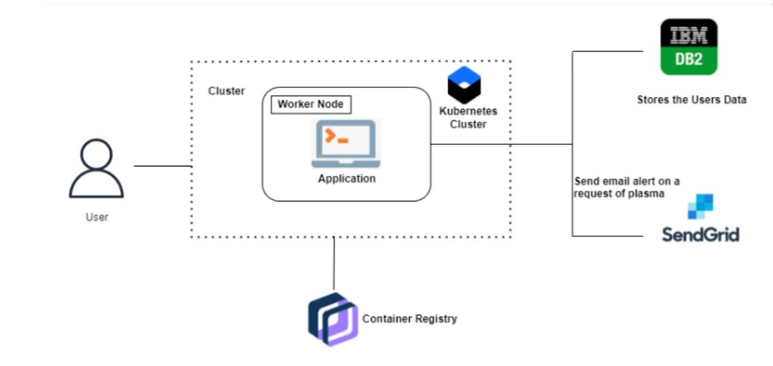

* **User Interface**

